IN104 : Intermediate Report

Sophie Patras and Lucille Gimenes

Mai 2020

1. Langage and framework

For this project, we chose to use Python, because it was the computer language we were the most comfortable with. Indeed, we thought it would allow us to go further in the development of the app. Therefor, Kivy was the framework to work with. This free library from Python enables to create touch-sensitive applications, with an easy user interface.

To create the app, we had to use several packages (from Kivy or not) :

* *KivyMD* : this is a collection of material design widgets which allow to create a designs very close to Google’s ones.
* *Mapview* : this widget enables to work with interactive maps.
* *HERE* geocoding and search service : this API geocoder helped us create a research bar which returns coordinates on the map from an address.
* *Squilte3* : this database engine was useful to treat the data we wanted to implement on the map.

1. General organization of the map

Our app, which is named “MAlPes”, is doomed to be used by hikers in the Alpes. Indeed, the application displays the location of mountain refuges, and also provides information on each one of them. The user can also search a place from its address.

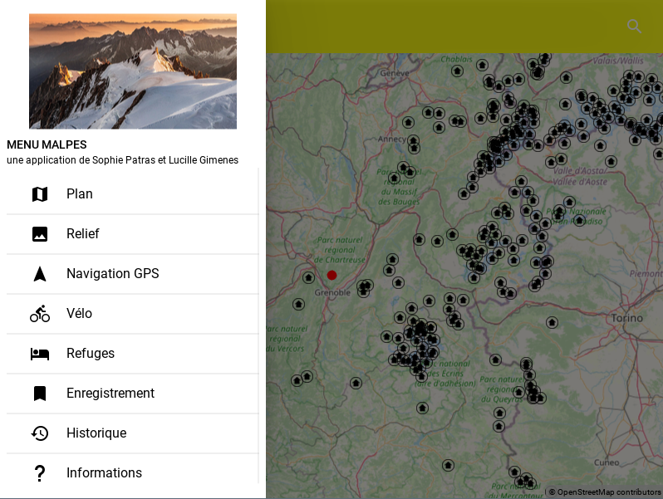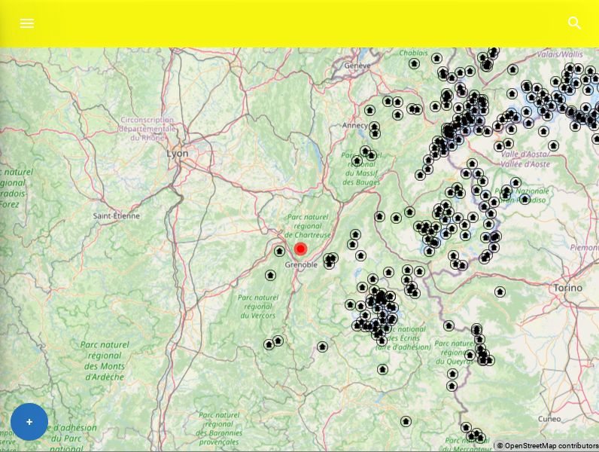

What we would like to add is GPS location on the map, we are close to the point.

We also have created a navigation drawer, which would allow the user to change some parameters or to save some locations ; we are still working on that part.

1. Challenges encountered

At first it was a bit hard to properly install and use the packages such as kivymd and mapview. Also the kivy structure is quite complex, and not really easy to handle. Nevermind we are now more comfortable with this.

An other issue is to implement the app on Android, we are still figuring out how to do it.

Annexe Asana